1. **Alarm should sound in one manner if temp is above 60 C**

**Coding:**

void setup()

{

pinMode(12, INPUT);

pinMode(13, OUTPUT);

}

void loop()

{

if (digitalRead(12) == HIGH)

{

digitalWrite(13,HIGH);

}

else

{

digitalWrite(13, LOW);

}

delay(10);

}

**Circuit Diagram:**

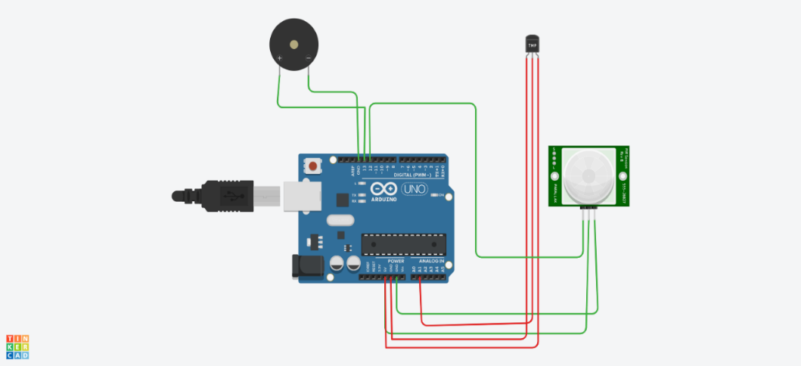

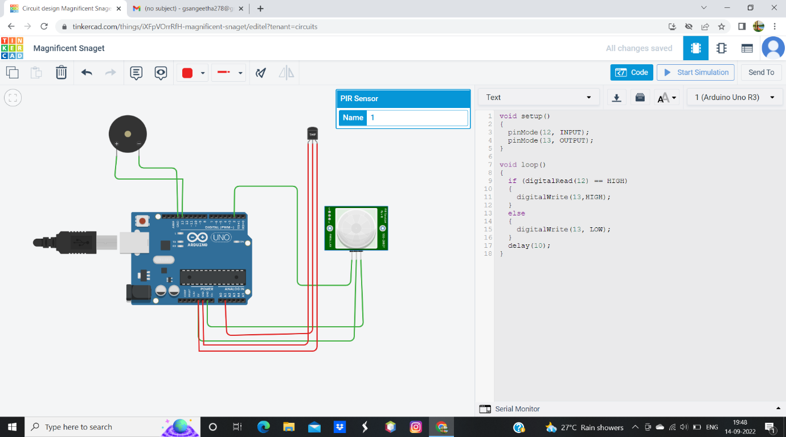

1. **Alarm should sound with another frequency if motion is detected in PIR sensor.**

**Coding:**

// c++ code

//

void setup()

{

Serial.begin(9600);

pinMode(13,OUTPUT);

}

void loop()

{

int data=analogRead(A0);

double n=data/1024;

double volt=n*6;

double off=volt-0.6;

double temperature=off*100;

Serial.print("Temperature data:");

Serial.println(temperature);

tone(13,100);

delay(1000);

tone(13,200);

delay(1000);

}

**Circuit Diagram:** 